National Biosecurity Communication and Engagement Network

Biosecurity Incident Public Information Manual Part 1 – Public information policy
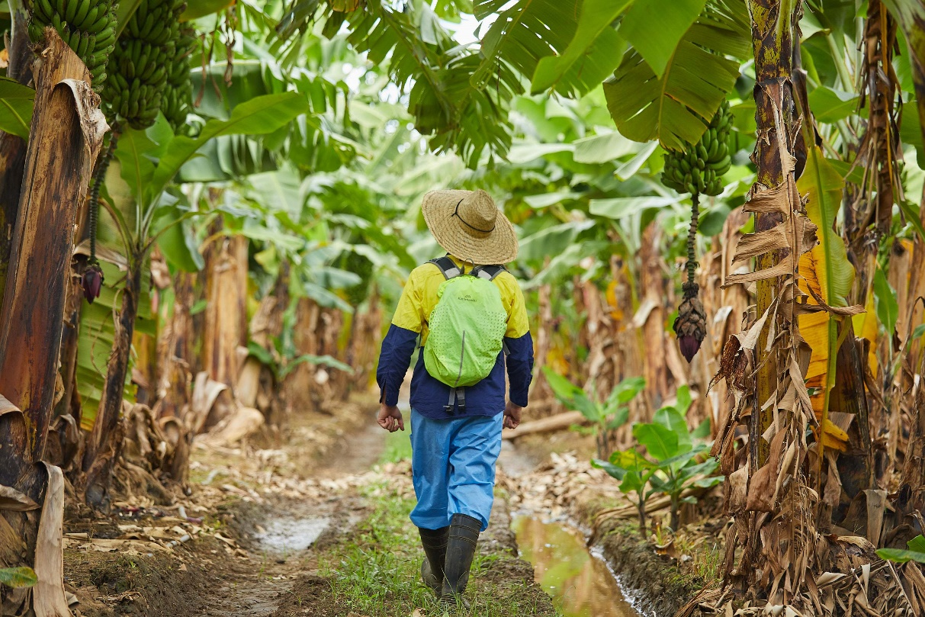
© Commonwealth of Australia 2026
Ownership of intellectual property rights
Unless otherwise noted, copyright (and any other intellectual property rights) in this publication is owned by the Commonwealth of Australia (referred to as the Commonwealth).
Creative Commons licence
All material in this publication is licensed under a Creative Commons Attribution 4.0 International Licence except content supplied by third parties, logos and the Commonwealth Coat of Arms.

Cataloguing data
This publication (and any material sourced from it) should be attributed as: NBCEN 2026, Biosecurity incident public information manual: Part 1 – Public information policy, National Biosecurity Communication and Engagement Network, Canberra. CC BY 4.0.
This publication is available at outbreak.gov.au.
Department of Agriculture, Fisheries and Forestry
GPO Box 858 Canberra ACT 2601
Telephone 1800 900 090
Web agriculture.gov.au
Disclaimer
The Australian Government acting through the Department of Agriculture, Fisheries and Forestry has exercised due care and skill in preparing and compiling the information and data in this publication. Notwithstanding, the Department of Agriculture, Fisheries and Forestry, its employees and advisers disclaim all liability, including liability for negligence and for any loss, damage, injury, expense or cost incurred by any person as a result of accessing, using or relying on any of the information or data in this publication to the maximum extent permitted by law.
Acknowledgements
The BIPIM is produced by the National Biosecurity Communication and Engagement Network (NBCEN). NBCEN is made up of agricultural health organisations and communication representatives from the Australian Government and state and territory agencies responsible for biosecurity.
Acknowledgement of Country
We acknowledge the continuous connection of First Nations Traditional Owners and Custodians to the lands, seas and waters of Australia. We recognise their care for and cultivation of Country. We pay respect to Elders past and present, and recognise their knowledge and contribution to the productivity, innovation and sustainability of Australia’s agriculture, fisheries and forestry industries.
Important information
Emergency Animal Disease Hotline 1800 675 888
Exotic Plant Pest Hotline 1800 084 881
National pest and disease outbreaks website outbreak.gov.au
Credits
Cover photo: © Banana plantation inspection. Queensland Department of Primary Industries.
Version control
Version | Date of issue | Author | Comments
V1.0 | April 2014 | Biosecurity Incident National Communication Network (NCN) | Endorsed by the National Biosecurity Committee February 2014
V2.0 | May 2018 | NBCEN | Endorsed by NBCEN November 2017
V3.0 | June 2026 | NBCEN | Endorsed by NBCEN March 2026

Contents
Introduction 4
Using the BIPIM 5
Who it’s for 5
What’s in it 5
Why public information is important in an incident 6
Impacts of biosecurity incidents 7
Incidents involving animals 8
Language considerations 8
Response arrangements in Australia 10
National response arrangements 11
Biosecurity incident response arrangements 12
Public Information coordination 16
NBCEN 16
Delivering messages between agencies and organisations 17
Evaluation and review 18
Incident response evaluation 18
Review and update of the manual 18

Tables
Table 1 Incident Management Team function description 11
Table 2 Public messaging delivery responsibilities 17

Figures
Figure 1 Fully expanded AIIMS structure 10
Figure 2 National crisis coordination arrangements 12

Introduction
The Biosecurity Incident Public Information Manual (BIPIM) enables the Australian Government and state/territory agriculture agencies to apply a nationally consistent communication and engagement response to biosecurity incidents. Biosecurity incidents are caused by pests, diseases or weeds that can impact on Australia’s:
- animal health (terrestrial and aquatic, including zoonotic diseases)
- plant health
- environment (including marine)
- human health
- social amenity and way of life.

Using the BIPIM

Who it’s for
This manual is a guide for people performing communication and stakeholder engagement roles in a state or territory agency, or the Australian Government, in response to a biosecurity incident.
The BIPIM is a product of the National Biosecurity Communication and Engagement Network (NBCEN). NBCEN is responsible for its review and publication, and for granting permission for its use in public information training modules.

What’s in it
The BIPIM is divided into 4 parts:
- Part 1 gives an overview of public information policy and describes national biosecurity arrangements, including systems, processes and the role of public information.
- Part 2 describes public information operations and processes, while providing guidance on how to implement effective communication and engagement during a biosecurity incident.
- Part 3 contains job cards specific to the public information units and describes roles, responsibilities, tasks, skills and knowledge required.
- Part 4 contains templates, forms and checklists.

Why public information is important in an incident
‘Public information’ is information provided to the public immediately before, during and after an emergency to reduce the potential impact of an emergency or hazards (Australian Institute for Disaster Resilience, Public information and warnings handbook, 2021). In a biosecurity incident, information is disseminated to and received from affected industries, trading partners, the media and public, other stakeholders, and staff within an agency/organisation.
The role of government in a biosecurity response is to provide timely, relevant, up-to-date, accurate and consistent information about:
- the pest, disease or weed and its impact
- the need for protective measures to stop the spread (biosecurity measures)
- movement controls
- the community’s reporting and response obligations.
Doing this well increases the chances of successful response outcomes and reduces the risk of community resistance to biosecurity measures. Good public information helps the community and affected stakeholders prevent the spread of pests, diseases and invasive species, which aids containment, control and eradication efforts.
For example, during the banana freckle eradication response in Darwin, backyard banana plants within designated zones were removed. This led to considerable resistance from some residents who did not understand why their healthy plants needed to be destroyed. Earlier engagement and clearer communication about the reasons for removal would have helped the community accept and support the action.
In addition to assisting with the response, keeping the public informed improves the perceived effectiveness of a response and can assist with recovery. As Bruce Esplin, former Emergency Services Commissioner for Victoria, said after the Black Saturday bushfires in 2009:
Communication is the critical thing and if you do not do it right you will be judged to have failed, regardless of what else you do with your fire trucks and your response.
(Bruce Esplin, Emergency Management Public Affairs Conference, May 2009)
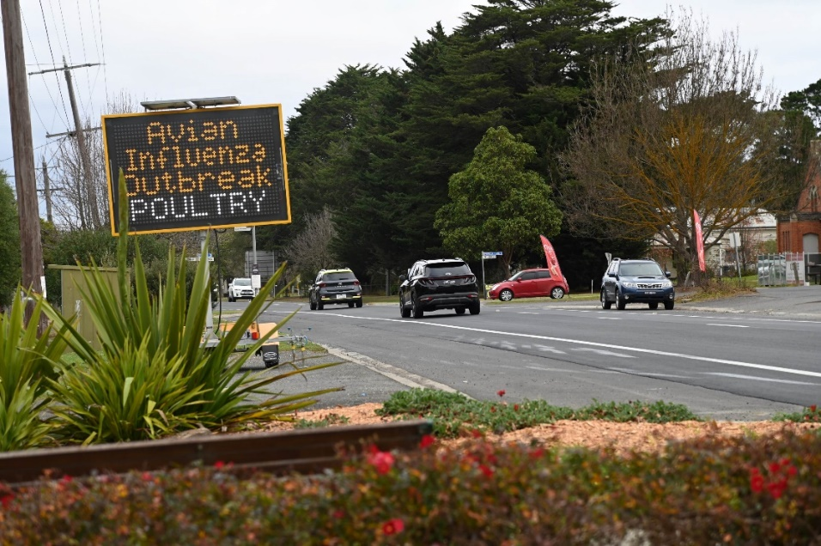
Photo courtesy of Agriculture Victoria.

Impacts of biosecurity incidents
Plant and animal pest and disease incursions and other biosecurity incidents can have devastating impacts on our primary industries, native wildlife, environment, communities and economy. They can:
- impact our agricultural, seafood and forestry industries
- compromise our clean air, water and land
- lead to crop losses and the destruction of animals
- damage our unique natural environment and ecosystems
- cause lost income and affect market access
- affect community connection and cohesion, including mental health.
Some incidents occur over an extended period, resulting in long-term economic losses and social impacts. Certain pests and diseases can also cause unique and specific cultural impacts for First Nations and other communities.
There have been incidents with far-reaching impacts beyond the immediate industry, affecting the broader community, related sectors and the environment. One example is the 2007–08 equine influenza incursion, when many people with no direct connection to horse ownership experienced financial hardship, including staff at racecourse restaurants and at a charity that supported people with disabilities by providing a cleaning service for saddle blankets and horse rugs.
Australia’s favourable export trade status can also be affected because certain pests and diseases, when confirmed as new to Australia, must be reported to trading partners through the World Organisation for Animal Health or International Plant Protection Convention. When this notification occurs, it can trigger international trade restrictions on affected plants and produce, animals and associated products.

Incidents involving animals
When animals are destroyed for disease control purposes the community can become upset, hostile and uncooperative. One example of this was the 2001 outbreak of foot-and-mouth disease in the United Kingdom. As part of the response to this disease, infected and suspect animals were destroyed and disposed of en masse. Extensive media coverage was given to the resulting mental health, economic and environmental issues that affected many farmers, their families, and surrounding communities.
In Australia, diseases such as avian influenza have resulted in losses of millions of poultry and eggs. Hendra virus has taken the lives of horses and people, and the potentially fatal canine ehrlichiosis (Ehrlichia canis) continues to impact dogs across northern Australia.
Many people hold a high level of emotional attachment to their animals. Acknowledging this and showing empathy is important, especially through public spokespeople.
Some incidents can spark national and international public concern and attract the attention of animal welfare activists. These situations often lead to diminished trust in government and industry processes and can erode the government’s social licence to operate. To help maintain public confidence, it’s essential to provide timely, accurate information and engage transparently with stakeholders. Ensuring that trusted sources of truth are available helps balance public debate. Additionally, government and industry spokespeople should communicate with empathy and demonstrate a clear understanding of the impacts – this is a vital component of effective public communication during any incident or disaster.
[NBCEN member reference: Maintaining stakeholder social licence to support EAD responses – communications framework]

Photo courtesy of S Gibbons.

Language considerations
Producers, industry professionals and the public respond differently to messaging. When targeting communications, consideration needs to be given to the language, the tone and who may be best placed to deliver the message. Trusted networks, local voices, and culturally appropriate methods are key to ensuring effective engagement and compliance.

Response arrangements in Australia
Biosecurity and agriculture agencies use well-established and nationally agreed arrangements to respond to pest and disease emergencies. The Australasian Inter-service Incident Management System (AIIMS) is the nationally recognised system used by Australian emergency service agencies to respond to incidents such as floods and fires. Most jurisdictions base their response system on AIIMS.
AIIMS is based on 6 fundamental principles:
- safety first
- management by objectives
- functional management
- span of control
- flexibility
- unity of command.
All biosecurity incidents require some level of communication support. The Public Information function is therefore scalable and can be applied across all incidents, regardless of the incident level or scale of impact.
Figure 1 Fully expanded AIIMS structure
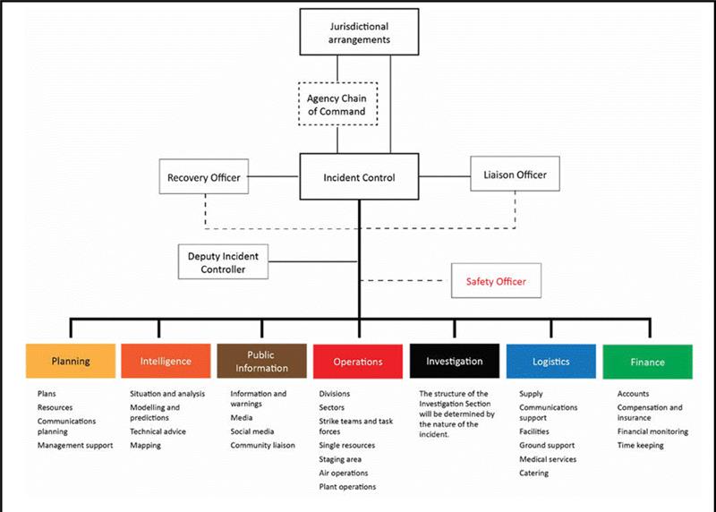
Source: Australasian Fire and Emergency Services Authorities Council 2025, The Australasian Inter-service Incident Management System, AFAC, Melbourne.
Figure 1 shows the AIIMS incident management structure used by Australian emergency services. Biosecurity agencies have adapted this structure for use at a Local Control Centre (LCC), State Control or Coordination Centre (SCC) or National Coordination Centre (NCC). The size of an Incident Management Team (IMT) can be scaled up or down, depending on the level of response required.
Table 1 Incident Management Team function description
Function | Description
Control | The management of all activities necessary for the resolution of an incident.
Planning | The development of objectives, strategies and plans for the resolution of an incident and management of immediate consequences for the community.
Intelligence | The task of collecting and analysing information or data, which is recorded and disseminated as intelligence to support decision making and planning.
Public Information | Provision of warnings, information and advice to the public, and liaison with the media and affected communities.
Operations | The tasking and application of resources to achieve resolution of an incident.
Investigation | The task of conducting investigations to determine the cause of an incident and/or to determine factors that contributed to the impact of the incident or specific events.
Logistics | The acquisition and provision of human and physical resources, facilities, services and materials to support achievement of incident objectives.
Finance | The task of managing:  - accounts for purchases of supplies and hire of equipment  - insurance and compensation for personnel, property and vehicles  - the collection of cost data and provision of cost-effective analyses and providing cost estimates for the incident.
Source: Australasian Fire and Emergency Services Authorities Council 2025, The Australasian Inter-service Incident Management System, AFAC, Melbourne.
Table 1 describes what each IMT function is responsible for during an incident. Note that the Intelligence function may operate within the Planning function, and Finance may operate within Logistics.

National response arrangements

Australian Government crisis management arrangements
During a crisis the Department of Agriculture, Fisheries and Forestry (DAFF) works with other Australian Government agencies under the Australian Government Crisis Management Framework (AGCMF). This policy frames Australia’s national crisis management arrangements and outlines:
- the Australian Government’s approach to preparing for, responding to and recovering from crises
- roles and responsibilities of Australian Government ministers and senior officials
- key Australian Government tools and mechanisms to support coordination during crises.
The Australian Government Biosecurity and Agricultural Response Plan (AUSBIOAGPLAN) describes DAFF’s role as the coordinating agency for biosecurity or agricultural incidents. DAFF owns the plan and activates it when warranted.
Figure 2 shows how DAFF’s Incident Management Team works with other Australian Government agencies during a crisis.
Figure 2 National crisis coordination arrangements
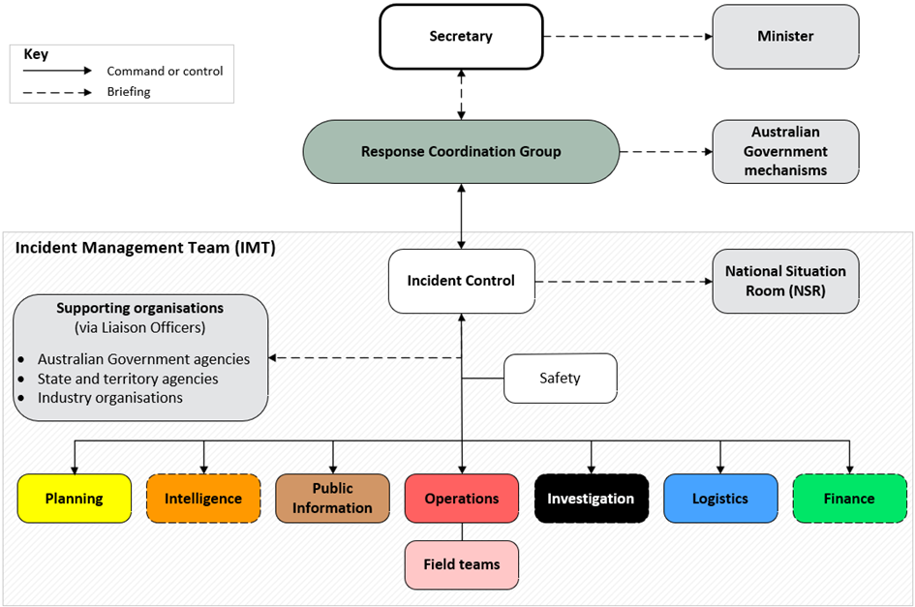

Crisis appreciation and strategic planning
The crisis appreciation and strategic planning (CASP) methodology is used by governments to prepare for, respond to and recover from a crisis. The CASP process is a repeatable, strategic-level planning model. It uses a structured method to integrate and analyse information from multiple sources. It helps by:
- building situational awareness
- interpreting complex situations
- undertaking operational strategic foresight and planning
- developing a shared understanding of incident priorities and efforts.
The Public Information function should always be part of any CASP process.
More information about CASP is on the National Emergency Management Agency (NEMA) website.

Biosecurity incident response arrangements
Biosecurity responses in Australia are supported by a range of state, territory and Australian Government legislation, as well as several legally binding emergency response agreements. All impose certain obligations and provide powers to enable certain response actions. The frameworks that apply vary with the nature of the incident, including the type of pest or disease, where it is found, and the parties most affected.
State and territory governments have biosecurity legislation that allows actions to mitigate biosecurity risks. Australian Government legislation, including powers under the Biosecurity Act 2015, is available to support the states and territories (and some external territories) where appropriate.
The state and territory governments are responsible for the on-ground response activities in their jurisdiction – for example, destruction and disposal, movement controls, tracing and testing.
Irrespective of the incident level and combat jurisdiction(s) (the state(s)/territory(ies) leading the response), DAFF is responsible for dealing with national issues such as biosecurity risks at the Australian border (incoming passengers, mail and cargo) and international trade issues (imports and exports to and from Australia of live animals and agricultural products).

Classification of biosecurity incidents
Biosecurity incidents are assigned an appropriate level of coordination, resources and support:
- Level 1 – local response managed by local resources, with little or no external support
- Level 2 – local or regional response, with some support coordinated by a state or territory agency
- Level 3 – state/territory-wide response with a fully operational State Coordination Centre and Local Control Centre(s) and possibly assistance from outside the jurisdiction
- Level 4 – response involving management by one or more jurisdictions and a National Coordination Centre established to coordinate nationally available resources
- Level 5 – response involving management by one or more jurisdictions and a National Coordination Centre established to coordinate national and international resources.
When a biosecurity incident occurs, an Incident Controller is appointed and establishes the relevant team of a size capable of managing the incident. Under the Australian Veterinary Emergency Plan (AUSVETPLAN) and the Australian Emergency Plant Pest Response Plan (PLANTPLAN) arrangements the SCC is led by an Incident Coordinator. Where required, an NCC may also be established, with its own Incident Coordinator, to support inter-agency or cross-jurisdictional coordination. The distinction between ‘Controller’ and ‘Coordinator’ reflects nationally agreed biosecurity response arrangements in which Local Control Centres exercise operational control, while State Coordination Centres perform strategic coordination functions. Some incidents may combine state and local operations in one centre, and some jurisdictions may retain orthodox AIIMS terminology and use the terms State Control Centre and State Incident Controller.
People appointed to each section must possess the necessary skills and knowledge, and preferably experience, to carry out the duties of the role. Public Information roles are described in more detail in BIPIM Part 3.
The AUSVETPLAN control centre management manuals have more detailed information on setting up control and coordination centres for handling emergency animal diseases.

Phases of biosecurity incidents
The following are phases of a biosecurity incident. Jurisdictions may choose to stand up their Public Information function during any phase, based on AIIMS scalability:
- investigation and alert
- operational
- stand-down.
The Public Information function will also apply during the recovery phase as the industry and community begin the transition to a new normal. Recovery can begin at any stage during the response – best practice is to commence with the response – and is likely to continue once response activities have concluded.

Response cost-sharing
Response deeds and agreements are legal contracts between governments and industry. These documents outline cost-sharing arrangements for the response and will be activated by the relevant national committee.
The response deeds and agreements include:
- Emergency Plant Pest Response Deed (EPPRD)
- Emergency Animal Disease Response Agreement (EADRA)
- National Environmental Biosecurity Response Agreement (NEBRA)
- National Management Agreement (NMA) – H5 HPAI for Wildlife.
Plant Health Australia and Animal Health Australia are custodians of the EPPRD and EADRA respectively, and DAFF is custodian of the NEBRA and the NMA.
In the initial stages of a response that is nationally cost-shared under the EPPRD or EADRA, a state agency or industry group should not release public information in isolation from other jurisdictions. Public information should be based on a set of national talking points, agreed to by all parties participating in the relevant consultative committee. The national talking points process is described in BIPIM Part 2.
If the pest or disease cannot be eradicated, the response may transition to management (T2M). T2M may be phased under the provisions of the EPPRD, EADRA or NEBRA.
The NMA is the nationally agreed arrangement for responding to H5 high pathogenicity avian influenza (H5 bird flu) in wildlife, as eradication or containment of the disease is unlikely.

Consultative committees
Consultative committees operate in accordance with the relevant agreement (EPPRD, EADRA or NEBRA). The parties involved are the Australian Government, all state and territory governments, and affected industry groups that are signatories to the EPPRD or EADRA. They are chaired by Australia’s chief veterinary, plant or environmental biosecurity officer.
For each sector response, the committee will be either the:
- Consultative Committee on Emergency Plant Pests
- Consultative Committee on Emergency Animal Diseases
- Aquatic Consultative Committee on Emergency Animal Diseases
- Consultative Committee on Introduced Marine Pest Emergencies
- National Biosecurity Management Consultative Committee.
The secretariats for these committees sit within DAFF.

National management groups
The National Management Group and the National Biosecurity Management Group endorse the specific pest or disease response plan proposed by the consultative committee. They decide on funding in line with the cost-sharing arrangements set out in the EADRA, in the EPPRD or under the NEBRA.
Members are:
- directors-general of biosecurity from the Australian, state and territory governments
- chief executive officers from affected industry organisations
- Plant Health Australia (observer)
- Animal Health Australia (observer).
The chair is the Biosecurity Deputy Secretary in DAFF.

Pest and disease strategies
Response agreements are supported by a series of response plans or strategies that set out the preferred approach to achieve containment, control and eradication of exotic pests and diseases.
- AUSVETPLAN guides the response to animal pests and diseases.
- PLANTPLAN guides the response to plant pests and diseases.
- AQUAVETPLAN guides aquatic animal disease responses.
There are 5 marine pest response manuals that provide guidance on responding to specific priority marine pests.
Public Information Officers working in a nationally cost-shared biosecurity incident response need to be aware of the basic provisions of the national agreements and their confidentiality and communication requirements.
Make yourself familiar with the agreements by completing the online courses developed by Plant Health Australia and Animal Health Australia, and courses available on the National Biosecurity Training Hub.

Public Information coordination

NBCEN
NBCEN leads and coordinates strategic communication and engagement for the biosecurity sector, with a focus on prevention and preparedness.
NBCEN’s core membership comprises relevant communication representatives from:
- the Australian Government (DAFF)
- state and territory primary industries departments or biosecurity agencies
- Animal Health Australia
- Plant Health Australia
- Wildlife Health Australia
- CSIRO’s Australian Centre for Disease Preparedness.
NBCEN is a subcommittee of the National Biosecurity Committee.

NBCEN Response Group
If a response is widespread or fast moving and requires an IMT to be set up by any jurisdiction, NBCEN will transition into the NBCEN Response Group (NRG), which allows for its membership to be expanded to include:
- the Public Information Officer and/or NBCEN representative from each jurisdiction
- representatives from other IMT functions (e.g. Operations or Planning), to inform the public information functions
- industry communication managers impacted by the response (from those organisations that are signatories to the cost-sharing deed or agreements)
- representatives from other Australian Government and state/territory agencies involved in the response (e.g. health, environment).
During a response any jurisdiction or organisation may request a meeting of the NRG. The NBCEN Secretariat will organise the meeting and, where required, prepare an agenda and record action items.
The NRG coordinates nationally consistent public information in response to all pest and disease (biosecurity) incidents. It operates under an ‘all hazards, all agencies’ approach.
NRG will circulate media releases, talking points and other public information products across jurisdictions and industry groups to enable consistent messaging and reduce duplicated effort.
During a biosecurity incident NRG:
- supports response activities outlined in the nationally agreed pest or disease response plan
- provides strategic communication advice to the relevant consultative committee and develops national talking points
- ensures national media and communication procedures for biosecurity incidents are activated and implemented accordingly
- provides tailored, accurate and clear information to audiences quickly
- facilitates the flow of information between jurisdictions (related to public information activities)
- provides experienced public information officers to other jurisdictions (where available through the jurisdictional deployment coordination mechanism)
- ensures the key principles of crisis communication and best practice are upheld throughout the response and into recovery.

Delivering messages between agencies and organisations
Table 2 identifies the responsibilities of the Australian Government, the states and territories, and industry for delivering messaging during a response.
Table 2 Public messaging delivery responsibilities
Australian Government | Combat jurisdiction | Industry
Messaging about:  - announcing national movement restrictions (if applicable) e.g. national livestock standstill  - Australia’s international border (passengers, mail, conveyances and cargo)  - consolidated national data  - national and international resourcing/deployments  - national funding/financial assistance  - national legislation  - national operations  - overarching biosecurity advice (keep out, keep clean, keep watch, report)  - advice to exporters and importers  - trade implications/market access  - vaccine imports/approvals | Messaging about:  - compensation processes  - compliance (enforcement, fine amounts)  - destruction, disposal, decontamination  - how to apply for grants  - how to apply for permits  - biosecurity practices  - restrictions  - state and localised data  - state authority responsibilities (who’s on the ground doing what)  - state borders  - state control measures  - state declarations  - state legislation  - state operations  - state resourcing | Messaging about:  - industry advice (back to governments)  - industry calls to action  - industry impacts  - industry-specific biosecurity plans and practices  - industry support (assistance) (resources/financial)  - impacts on the industry, for general public awareness

Evaluation and review

Incident response evaluation
Further information about debrief and after-action reviews is in BIPIM Part 2.

Review and update of the manual
The BIPIM will be reviewed by NBCEN every 2 years. A NBCEN working group will be established to lead this work.
Any lessons identified coming out of a response should be recorded and integrated into the next version.

